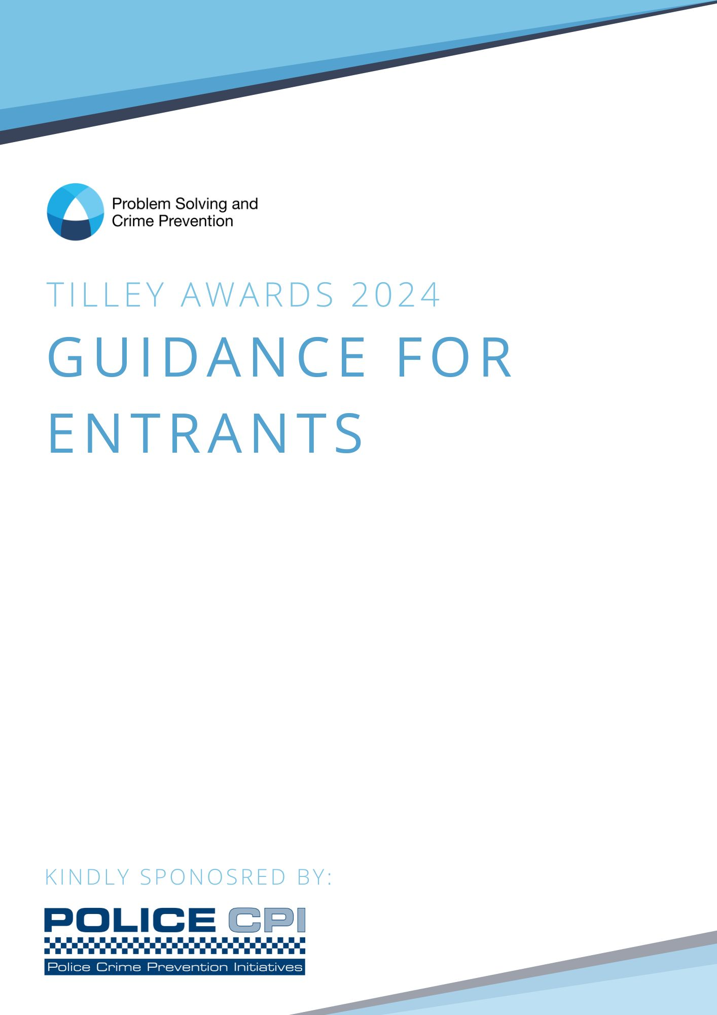
Contents

Introduction Page 3
Process & Milestones Page 5
Entry Requirements Page 6
Submitting your application Page 8
Judging Criteria Page 9
Help Page 11
FAQ’s Page 11

The Purpose of this guidance:
This guidance has been written for people considering entering the Tilley Awards 2023. The guidance has been designed to help you to:
- Decide whether your project is ready to be entered into the awards
- Put together the best possible application
- Understand the process for submitting an application
- Know what to expect once your entry has been submitted
Please read this guidance very carefully as any application that does not comply with the entry requirements will be rejected from the competition.
We want to provide you with as much help as possible and to this end, if you have any queries about your application, or the proper procedure to follow, please feel free to contact us using the details below:
Helen Eshelby | Awards and Events Manager
07464 985 393
Tilley_Awards@southyorks.pnn.police.uk

Introduction

It is helpful to understand the origins of problem solving when framing your project. The originator, Professor Herman Goldstein, was an academic who worked closely with the police. However, he quickly realised the police would often return to the same location, to deal with the same type of issue, time and time again. Often, they would repeat a similar response, which had been unsuccessful on previous visits. Professor Goldstein highlighted that repeat police incidents aren’t random but often concentrate in time and place, involving specific people and places. He therefore thought there was more scope to provide sustainable solutions to them, which would provide a better service for the public as well as reduce police demand.

However, to achieve this the police needed to adapt their approach. First, they had to be more systematic in identifying repeat calls as only by being specific in defining the problem could the police hope to solve it. Second, they had to recognise the underlying opportunities and characteristics that underpin repeat calls, rather than continuing to deal with the symptoms. Third, the police had to be more creative in tailoring solutions to tackle these underlying causes. To do this they often needed to go outside their normal police powers and work with others to find interventions that provided more sustainable solutions. In this process any technique or theory could be utilised if it assisted in providing a beneficial outcome. Finally, Professor Goldstein said the police should evaluate whether their response had made an impact. In this way they could better understand what worked and reduce wasted effort. These points were later incorporated into the SARA model and recent studies show this continues to be the most effective model to use. Prior to explaining the different stages, some wider comments are worthy of note.

First, Professor Goldstein recognised there are many long-term underlying causes that facilitate crime and disorder, and he embraced any approach that could be shown to reduce crime and disorder. However, as a pragmatism he argued the police didn’t have the capacity or capability to tackle issues such as poverty or deprivation. Nonetheless, he pointed out they were in an excellent position to block the opportunities that facilitate crime and disorder, immediately before it occurs. He emphasised focusing on this level would bring the most beneficial results.

Secondly, it is well documented that the SARA process isn’t linear. For example, after conducting analysis a practitioner may realise their problem is wrongly framed (i.e. it isn’t a crime problem, but a perception of a crime problem). Another example could be when members of the public criticise the police response or fail to engage in its implementation. This may reveal that community views weren’t fully considered during the initial analysis. These experiences are commonplace and simply require the practitioner to return to an earlier stage of the SARA process to complete some further work.

Third, applicants are encouraged to submit organisational problems to the award process. However, they should be mindful that good submissions will clearly explain the positive outcome generated by the process. For example, a HR initiative that reduces officer sickness levels, and releases more officer time to be spent on community activity, illustrates a clear outcome. In contrast an initiative that introduces a new internal process without clear evidence of community benefit would not be illustrative of good practice.

Finally, it is accepted that there are many excellent proactive policing operations, however these are not to be confused with problem solving approaches. Proactive policing operations are primarily enforcement based, rely on police activity, and whilst they can deliver exceptional, results these are generally short term. In contrast problem solving approaches are designed to provide a more sustainable solution, even after police resources are withdrawn.

The Tilley Awards, named after Professor Nick Tilley, were set up in 1999 by the Home Office to publicise the use of problem-oriented policing (POP), which provided more effective and sustainable solutions to police related incidents. These included crime, disorder, and public protection issues (such as child sexual exploitation and missing from home cases).

The awards were held for a number of years and were relaunched in 2018 as part of the Problem Solving and Demand Reduction Programme, led by South Yorkshire Police on behalf of all police forces across the UK. The programme is now referred to as the Problem Solving and Crime Prevention Programme.

The awards focus on the problem solving model, SARA (Scanning-Analysis- Response-Assessment), to emphasise the skills that have proven to have real results in terms of crime and disorder reduction and prevention. These skills include:
- Good and thoughtful problem analysis
- The clear identification of the underlying causes of crime and other incidents that create concern for local communities
- Implementing an evidence based response targeting victims, offenders and locations
- Robust evaluation to identify the impact a project has had on resolving the problem

The SARA model is the most commonly used model and is supported by the majority of academics in this field. However, other POP models are available and projects which can demonstrate each of the four SARA stages are eligible to enter.

A much more detailed practitioner guide to explain good practice in problem solving can be found at https://library.college.police.uk/docs/college-of-policing/Problem-solving_practitioner-guide.pdf

The process & milestones

29 January 2024 | Awards open for submissions at 09:00  Application forms are available to download:  APPLICATION PROCESS | National Problem Sol (problemsolvingconference.co.uk)  Alternatively please contact Tilley_Awards@southyorks.pnn.police.uk for an application form. Once you have completed your form please return it to Tilley_Awards@southyorks.pnn.police.uk
7 May 2024 | Applications close at 12:00  All applications will go to a shortlisting panel, made up of people with specialist knowledge and experience in different fields, who will individually score each of the applications before agreeing a final joint score. The shortlisting panel will be independent and unaffiliated to a particular area to ensure they are not scoring entries for areas where conflicts of interest arise.
15 July 2024 | Shortlist announced  The ten shortlisted submissions are announced and sent to the final judging panel who will score them using the same criteria as the sift judges.  The highest scoring entries will be announced on 23rd August 2024.
23 August 2024 | Finalists announced  The finalists will then be invited to present their project to the judging panel and attendees at the National Problem Solving Conference in October 2024.
October 2024 | Final judging  At the National Problem Solving Conference, the judges will score the project using good practice criteria. The audience will also be asked to score the finalists and they will be counted as one panel member. All the scores will then be averaged to determine the overall winner. Again, judges who have a vested interest in particular locations or organisations will not be permitted to submit scores for those entries.  The winner of the Tilley Awards 2024 is announced at the National Problem Conference Gala Dinner.
October | Feedback  Finalists will receive feedback on their project after the conference in October 2024. This will only be emailed to the project author and copied to the authorising representative.

The prize:
The finalists will be invited to present at the National Problem Solving Conference [1] to share their learning with delegates.

At the conference, the overall winner of the Tilley Awards will be announced.

The annual Tilley Award title will be retained by the successful project for one year. The winning project for the Tilley’s 2024 will also be invited to submit their winning application to the Goldstein Awards in the USA and have the opportunity to attend the International Problem Solving Conference in the USA in 2025. [2]

The remaining finalists will all receive framed certificates for those who led the project/partnership, and an award for winning their category.
[1] Conference and accommodation fees will be waived for two persons at the 2024 National Problem Solving Conference

[2] Flights and conference fees will be paid for by the funding from our sponsors – Police Crime Prevention Initiatives (PCPI)

Entry requirements
Eligibility:

The Tilley Awards are open to any police or partner organisations supporting crime prevention or community safety in England, Wales, Scotland and Northern Ireland (charities must be registered).
Entries from partner organisations must focus on reducing demand on emergency services and/or follow a relevant problem solving model but projects do not necessarily need an element of police involvement. However, police involvement is required for a project to be eligible for the International Goldstein Awards.

Some police forces hold their own internal force level competitions for problem oriented policing projects from which the best entries are then submitted to the Tilley Awards. Police officers considering submitting an application to the Tilley Awards should check with their senior representative, such as a Superintendent or Chief Officer, before entering the Tilley Awards to prevent duplicate entries about the same project.

There are no restrictions on the number of applications that can be submitted by the individual agencies or organisations.

Conditions:

It is a condition of entry that all final applications submitted to the Tilley Awards are authorised by a senior representative from each of the organisations involved in the delivery of the project. This is to ensure that all entries are factually correct and to prevent duplicate projects from different partnership agencies being submitted.

Authors are required to confirm their application has been endorsed on the application form. A hard copy signature is not required for the purpose of the form.

Entries that are not endorsed will be returned to the author. Statements of endorsements are not required. However, applicants should note that a randomised sample of entries will be checked, to confirm that the relevant senior representative, named on the application, has seen the submission.

What can an entry be about?

Entries should be about innovative and effective problem oriented projects that have achieved measurable success in resolving issues faced by the police, partners and/or the community.

To comply with the problem solving approach, applications should address repeat problems or issues that are of key concern to police, partners and/or communities, demonstrating a sustainable and evaluated response. All entries must be able to clearly demonstrate they have followed the problem solving model i.e. scanning, analysis, response and assessment.

The judging panel welcomes innovative projects that seek to use creative and varied responses provided they address all elements of the SARA model.

Good problems for problem solving may feature:
- Behaviours, not things e.g. shootings, not gangs
- Tractable, not intractable e.g. marital violence, not marital breakdown
- Patterned, not random e.g. repeat victimisation, not oil spills
- Recurrent, not occasional e.g. high crime neighbourhood, not periodic blip
- Community, not police management concerns e.g. village speeding, not efficient car use

Specific examples could include:
- Road casualties
- Anti-social behaviour on mischief night
- Child sexual exploitation
- Domestic abuse
- Repeat offending at a specific location/in a certain area

Small Print:
The below applies to all applications:

- If your project is selected as a finalist, you agree to present it at the National Problem Solving Conference in October 2024. Conference fees and accommodation costs will be waived for two persons however presenters are responsible for their own travel expenses.
- Entrants are not permitted to contact any member of the judging panel for advice outside of the official help/advice route. Doing so will result in your project being disqualified.
- Entries submitted after 12.00 on Friday 26th April 2024 will not be accepted.
- The judges’ decision is final and all applicants must abide by their decision.
- All submissions must have been initiated after January 2022. If entrants would like to submit an older application they must be able to provide evidence that substantial development has been made to ensure their application is accepted into this year's submissions.
- If applications are based on a pre-existing concept, entrants must be able to prove that significant adaptations have been made to make the submission valid.
- Applications must be filled out in full to be accepted into this year's submissions. Please double check your submission before sending to the programme team.
- Applications must adhere to the instructions detailed in the application form.
- Entrants must inform all partner agencies involved in the project of their submission to avoid any duplication of entries. Upon submitting your application form, you confirm that you have informed all relevant organisations.
- All applications must be endorsed by senior representatives from all partners covered by the application. It is the endorsing officer’s responsibility to ensure that the material facts of the application are accurate and that all other agencies who have played a role in the project delivery are informed of the submission.
- All information supplied on the application form will be made available through the Problem Solving & Crime Prevention Knowledge Hub page once the overall winner has been announced.
- Information may be shared in a variety of formats and media and by making an entry applicants are confirming their acceptance of this. Authors should ensure that entries do not contain material that is of a sensitive nature. Any entries submitted to the competition that transpire to contain sensitive information may be withdrawn from the competition.
- If removing sensitive information from your application form alters the integrity of your entry, please contact the programme team and we will evaluate on an individual basis.
- Entrants can view the programme’s full privacy policy on the Tilley Awards page of the Knowledge Hub.
- Applicants can use graphs and photos to aid in explaining elements of the project, however other audio and visual materials such as video clips, radio adverts etc. should not be included. The application will be judged on the text descriptions of the project and the learning at each of the four stages within the SARA model.
- Scanned newspaper clippings, posters etc. are also not permitted as a separate document but may be included in the body of your application.
- Excel spreadsheets and other mediums detailing collections of data will not be accepted. Entrants should try to summarise this information and include in the main body of your application.
- Projects that have previously been entered to Tilley Awards processes and not reached the shortlist or finals may be resubmitted provided additional work, or further assessment, has been carried out.
- If you have developed a project in your area as part of addressing a national policy drive or initiative (such as PREVENT, National Vulnerability Action Plan) you will be required to explain any constraints or requirements placed upon your area when developing your project.

Submitting your application

- Entrants can submit their application to Tilley_Awards@southyorks.pnn.police.uk
- If you have any questions about how to fill in the application form, please do not hesitate to contact the programme team.
- Applications should be submitted to Tilley_Awards@southyorks.pnn.police.uk
- The programme team will send a formal receipt upon receiving your application within 1-2 working day(s). If you do not receive confirmation, please contact the programme team.
- All entries must be received by 12pm on Tuesday 7th May 2024. Any entries not received by this date will not be eligible for the awards under any circumstances. It is the responsibility of the applicants to ensure that entries have been received by the deadline.

The judging criteria
Both the sift judges and the final judging panel are asked to score the strengths and weaknesses of the entry using the following criteria, which we strongly suggest you adhere to in preparing your entry.

Scanning:

The purpose of the scanning section is to be specific in defining the problem and show the level of harm it creates. It describes what is happening. Good projects illustrate:

The purpose of scanning is to define the specific problem to be addressed and to establish its extent. Good scanning:
- Highlights the specific nature of the problem (e.g. that it generally concentrates around a specific location or individual(s) and occurs at particular times).
- Provides evidence that the problem exists, is recurring, and is police relevant (i.e. the public view the problem as something the police should be tackling).
- Provides evidence of the extent of the problem, which can also act as a baseline for estimating the impact of the responses which are later put in place (e.g. police call data, or surveys to show local concern).
- Utilises diverse information sources to help illustrate the extent of the problem and associated harms (e.g. ambulance data and police data on numbers and locations of violent incidents).
- Describes the objectives for the problem-solving project – what does it seek to achieve?

Analysis:

The purpose of analysis is to explain why the problem behaviours take place at a particular time and place, involving particular people. Why, for example, does the antisocial behaviour take place on that specific street corner, or why do high levels of violence or theft occur in a particular licensed premise, or why do children go missing from some care homes and not others? To do so, the underlying causes or characteristics that facilitate the selected problem should be identified. Good analysis:
- Effectively explains what makes the target (person or object) vulnerable; and/or why the events occur at a specific location, and/or at specific times; and/or what leads those involved in the problematic behaviour to act as they do. The use of analytical tools or theories can assist at this stage (e.g. the use of the problem analysis triangle, based upon Routine Activity Theory).
- Draws on a variety of information sources (e.g. community, partner, or previous attempts to solve the issue).

Note: One of the most common mistakes in this section is that the applicant describes the offender / victim/ location in more detail, without regard to the opportunities for crime or disorder that enable the incidents to take place. Whilst the Problem Analysis Triangle is particularly useful for analysis of localised neighbourhood problems, more complex problems may require more. For example, organised crime offences may benefit from an understanding of where and how the profits are maximised, the composition of networks, and the processes through which the offending occurs (e. g. transportation, security).

Response:

The purpose of the response section is to identify promising points where effective interventions may be possible, drawing on the results of the analysis. Good responses:
- Are listed and described in sufficient detail to understand how they were implemented.
- Are tailored to the elements that have emerged from the analysis and is cognizant of local context.
- May be based on wider evidence of what works and / or explain how the intervention should work in this specific context. For example, does the section use well documented approaches (rational choice theory) or use evidence supplied by the ‘what works centre’ (College of Policing)?
- May involve relevant partners / community groups who can impact on the problem, rather than relying solely on the police. (Note, it is accepted that not all problems require a partner).
- Stand out due to their originality, creativity, or ability to blend a number of good interventions into a cohesive whole.

Assessment:

The purpose of the assessment section is to establish whether the intervention has made an impact on the selected problem. Good assessments:
- Provide a credible description of the period before and after the intervention. This utilises the baseline provided in the scanning section and indicates a suitable period over which to assess impact. If percentages are used, they should be supplemented by the raw figures as percentages based on low numbers can be misleading.
- Refer to the sustainability of the impact. For example, sustainability is evident due to the period of the evaluation, or a rationale is provided to explain why the impact is likely to be sustainable.
- Make reference to the possibility of displacement and assess it’s likelihood.
- Acknowledge gaps in the assessment, or unintended consequences emerging from the intervention.
- Show awareness of the dangers surrounding ineffective assessment (e. g. an unusual spike in the data, seasonal behaviour) and use techniques to mitigate this (e. g. use control samples, or longer periods for pre and post assessment).
- Where possible use financial information to evaluate the cost of the intervention compared to its benefits (Note the use of Home Office cost of crime information provides a verified and consistent approach). https://assets.publishing.service.gov.uk/government/uploads/system/uploads/attachment_data/file/954485/the-economic-and-social-costs-of-crime-horr99.pdf).

Presentation:

How a submission is presented is important. Good presentations ensure that:
- The submission meets the required word length and the key elements for each stage of the SARA process are presented in a logical and structured manner.
- Diagrams, media articles, or maps are used in moderation. They should be inserted to supplement the text, rather introducing a new point.
- Any charts or diagrams are given titles, clearly described, and are labelled to show what is being measured.
- The submission is written in plain English, with acronyms or special tactics explained, enabling a layperson to understand what is meant.

Note: These principles should also be used in any later oral presentation, should the author be asked to present.
Help

The Tilley Awards programme advisors can offer free advice on preparing a submission. The following assistance can be provided:

- An opinion on whether your project fits the definition of problem-solving partnership working
- Recommendations for collecting, analysing and presenting data relating to your project
- Feedback on your draft project narrative (only one draft project narrative is permitted per submission)

Applicants can send questions and draft project narratives to the programme team at Tilley_Awards@southyorks.pnn.police.uk. The team will anonymise the questions and drafts before sending to the panel of awards advisors, who are problem solving subject matter experts.

The awards advisors will be able to provide a reasonable level of assistance to any prospective applicant, however this assistance will be factually based and is intended to help you better present the good work done by your organisation.

Where possible, we will endeavour to reply to your questions and provide feedback on draft project narratives within 4-5 working days however occasionally the wait time may be longer. We therefore recommend that entrants consider this if they are planning to submit a draft narrative particularly if it is close to the submission deadline (12pm on Tuesday 7th May).

- You can find information on previous winners of the Tilley Awards on our Knowledge Hub page: https://knowledgehub.group/
- Alternatively, you can find previous submissions on the Center for Problem-Oriented Policing website, here: http://www.popcenter.org/library/awards/tilley.cfm?browse=abstracts
- You may find it beneficial to see details of the International Herman Goldstein Award, which are closely linked to the Tilley Awards. Previous winners of this can be found here: http://www.popcenter.org/library/awards/goldstein/

Written feedback will be emailed to the category finalists after the National Problem Solving Conference has concluded. The scoring system used is for internal marking purposes only and will not be made public.

FAQ’s
- Can I submit more than one application? - Yes. There is no limit on the number of applications that can be submitted from any one organisation.

- What happens if I miss the deadline? - Unfortunately, we are unable to accept applications that are submitted after the deadline so please bear this in mind when submitting your application.

- Can I include appendices with my application? - Applicants are welcome to use graphs and photos to aid in explaining elements of the project, however other audio and visual materials such as video clips, radio adverts etc. should not be included. Click here to see information about including other media.

- Do I have a guaranteed place at the National Problem Solving Conference? - No, unfortunately not. Submitting a Tilley Awards application does not guarantee you a place at the National Problem Solving Conference.
We reserve x10 places for the top 5 entries (two places per project) which will be announced on Friday 23rd August 2024 however, we recommend booking a place in advance to avoid disappointment.
You can email Problem_Solving_Conference@southyorks.pnn.police.uk to register your interest in this event.

- Can I submit my application if it does not follow the SARA model? - Yes, we appreciate that some partner organisations may follow different problem solving models. You can submit a project that does not follow the SARA model provided you can demonstrate the four stages of SARA have been included.

- I submitted last year and was unsuccessful, can I submit again? - Yes, provided you can prove that additional work or further assessment has been conducted since your last entry.

- How will I know that you have received my application form? - We will send you a receipt upon receiving your application within 1-2 working days. If you have not received a confirmation email within this time, please contact the programme team.

- When will I find out if I have been successful? - We will be announcing the top 10 shortlisted projects on Monday 15th July 2024. We will email the application author if you have been successful or unsuccessful so please ensure the contact details on your application form are accurate.
We will contact the 10 shortlisted projects via email on Friday 23rd August 2024 to inform you if you have been successful or unsuccessful.
The 5 finalists will present their projects at the National Problem Solving Conference in October 2024. The overall winner will then be announced at the Tilley Awards Gala Dinner.

