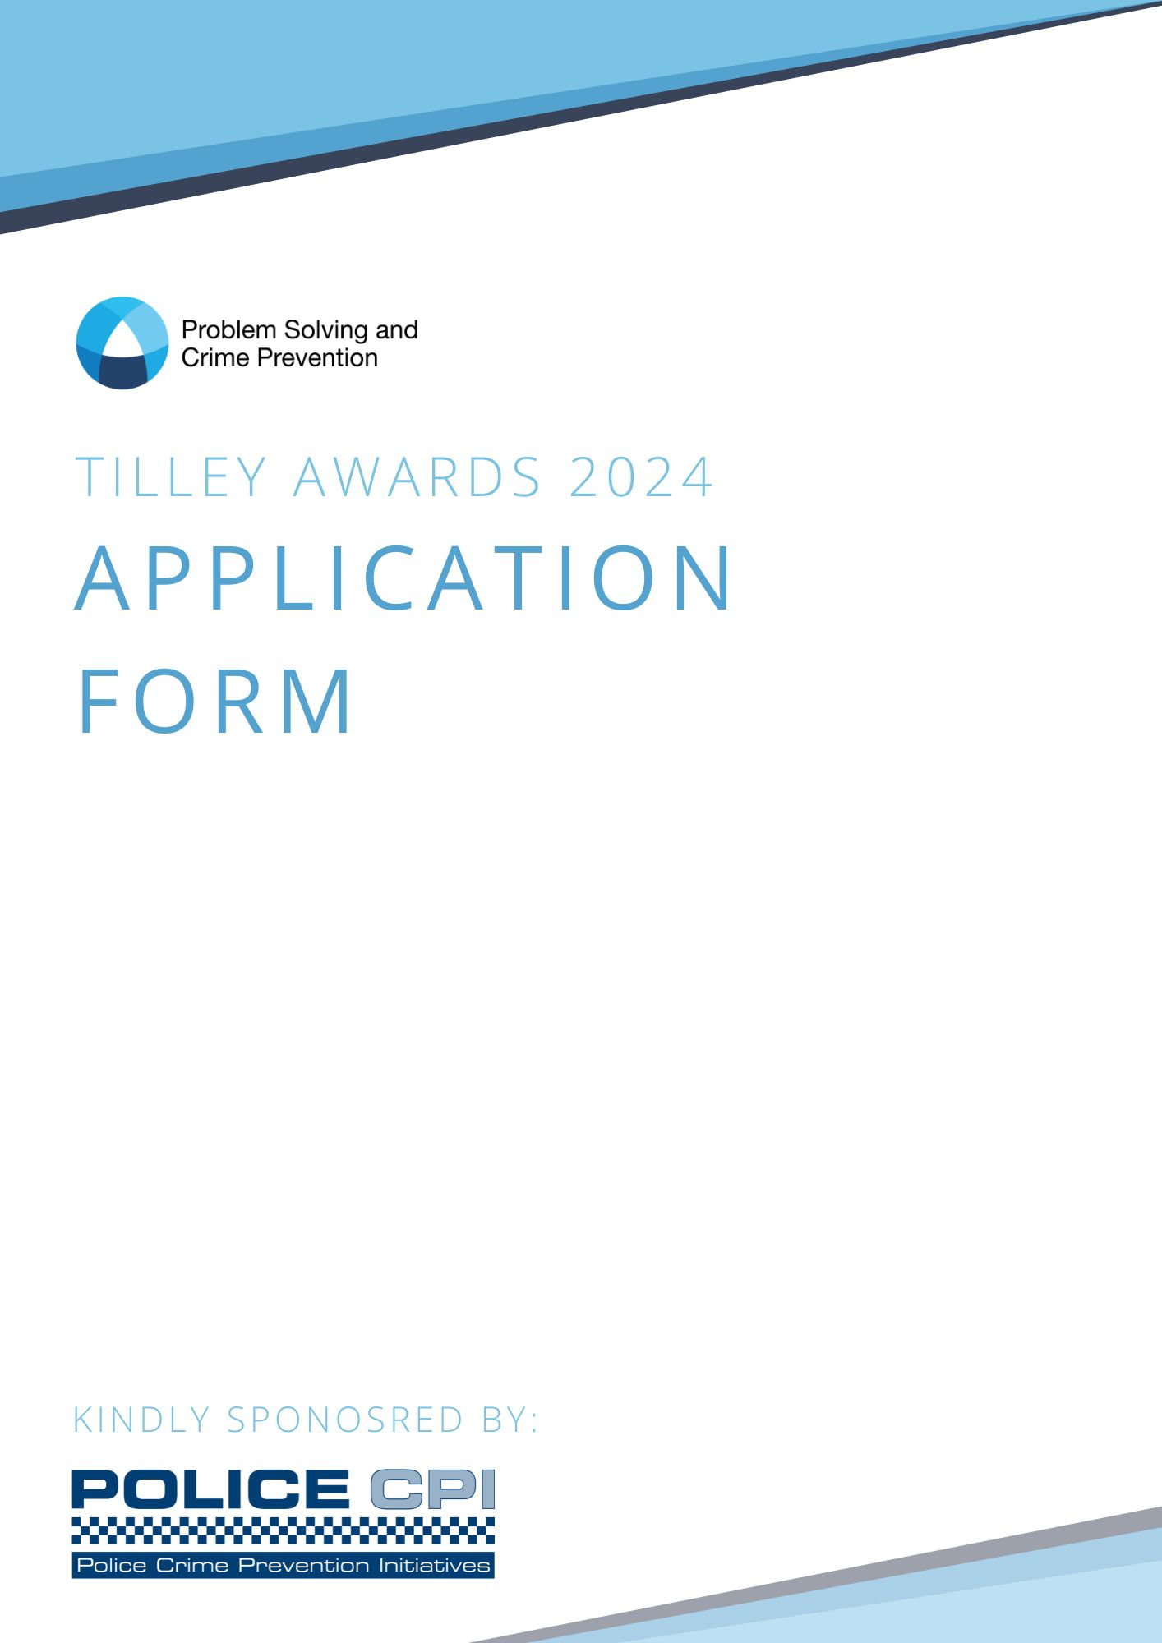

Information for entrants

Please ensure that you have read the guidance before completing this form.
By making an application to the awards, entrants are agreeing to abide by the conditions laid out in the guidance.

This application consists of four sections, as detailed below:

- Section A: Application information
- Section B: Summary of application
- Section C: Description of project
- Section D: Endorsement by a senior representative

Please complete the form in full, within the stated word limit. Failure to complete in full will result in your entry being rejected from the competition.
Completed word doc forms application forms should be emailed to: Tilley_Awards@southyorks.pnn.police.uk
All entries must be received by 12pm on Tuesday 7th May 2024. No entries will be accepted after this time/date. Any queries on the application process should be directed to Helen Eshelby at the email address above.

SECTION A - Application information

1. Title of Project:

2. Key issue/theme that the project addresses:

3. About you the author:
Please ensure you include all the requested information fully and accurately. We will use these contact details to inform you if your project has been shortlisted by Monday 15th July 2024.
Full Name:
Role:
Length of service:
Time in current role:
Would you consider yourself to be frontline, supervisor, middle management, senior management or executive?
Are you a student officer/police now:
Submitting organisation:
Email address:
Telephone number:

4. Secondary project contact details:
Full name:
Email address:
Telephone number:

5. Endorsing representative contact details:
Full name:
Email address:

6. List of agencies involved in the project and underline the lead organisation:
Please ensure you list all agencies involved in your project. Upon submitting your application, you agree that you have listed and informed all agencies involved of your submission.

☐ Please mark this box with an X to indicate that all organisations involved in the project have been notified of this entry.

7. Have you submitted this project in previous Tilley Award competitions?
☐ Yes
☐ No

8. If yes, please state which year:
Please ensure that the previous form is attached together with a detailed summary of changes and justification for resubmission.

9. Did you take advantage of the advice offered to applicants prior to entry?
☐ Yes
☐ No
10. If yes, did you find the advice beneficial?
Please provide a comment so we can continue to improve the awards process.

SECTION B - Application summary

11. In no more than 400 words please use this space to describe your project under the stated headings (see guidance for more information). The information in italics is provided to assist you in completing the form and should be deleted from your actual submission.

Summaries help the judges to gain a quick overview of the project before they read the main report. It is helpful to read the full report with a sense of context. Summaries for the shortlisted applications will be included in documentation used for the National Problem Solving Conference, and will be added to the Knowledge Hub. The summary should therefore be treated as an important, stand-alone document that provides a succinct description of the project. Although sections of the main report are likely to form the basis of the summary, these do need to be summarised rather than simply used in full length. Ensure Section B is no longer than 400 words and flows through the SARA model using the headings provided. The summary should not contain diagrams or charts. It should fit onto one side of A4.

Scanning:

Analysis:

Response:

Assessment:

Word Count:

SECTION C - Application description

Describe the project in no more than 4,000 words under the stated headings. Please make sure you use the guidance notes while completing this form.

Scanning:

Analysis:

Response:

Assessment:

Word Count:

SECTION D - Endorsement by senior representative

13. Please insert a letter or email from an endorsing representative.
The endorsing letter or email needs to confirm the senior representative (Superintendent or above) has authorised the submission of your application.

